Parser
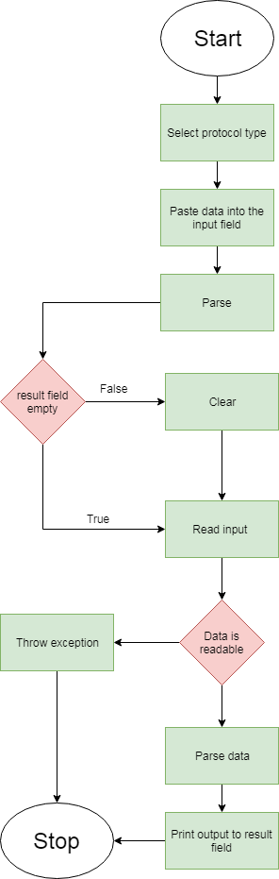
Illustration 1: Flow char of parser
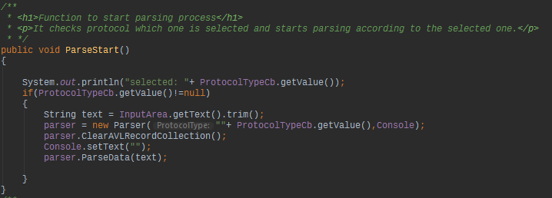
Class ParserView

When we enter the data in input text area, and select protocol type, we then press “Parse” button to start parsing. The first method that initializes parsing process is in ParserView class. The method checks if protocol is selected and proceeds to removing white spaces (trim). Clears any leftovers from previous parsing and calls ParseData method to begin parsing.
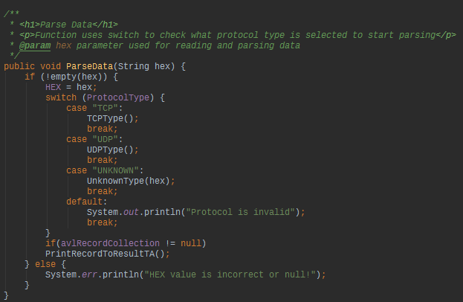
Parse Data method in Parser class

The method ParseData uses switch statement to check which protocol is selected and receives a hex from text area input. Calls out the parser for the right data. If protocol is not selected a simple default will be called and in console will say “Protocol is invalid”.
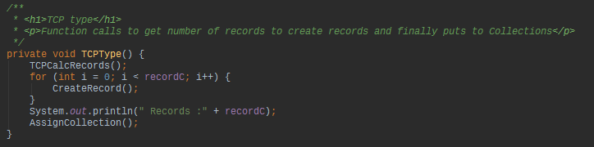
TCP type method in Parser class
TCPType method simply calls other few methods, first it calls a method to calculate the number of records in data. After that it runs over a for loop to create records, once its finished it assigns records to collection for further usages.
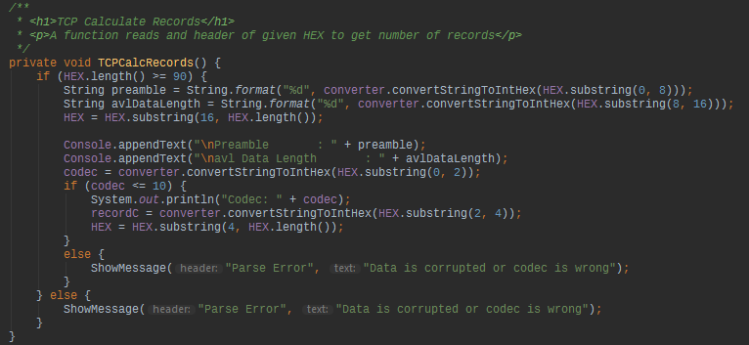
TCP Calculate Records method in Parser class

The method is called from TCPType to get information about data that is about to be parsed. It checks if data is even has at least 90 characters, if validation passes the information gathering begins, first of it starts with preamble, later on with avl data length. The HEX is being cut down and every time we parse something from it we cut it and make it shorter, we do this until no data to read is left.
After getting header it parses the codec and checks if its less than 10, other than that it will not parse. Once we pass the codec if statement, we collect the records count by simple parsing it from data.
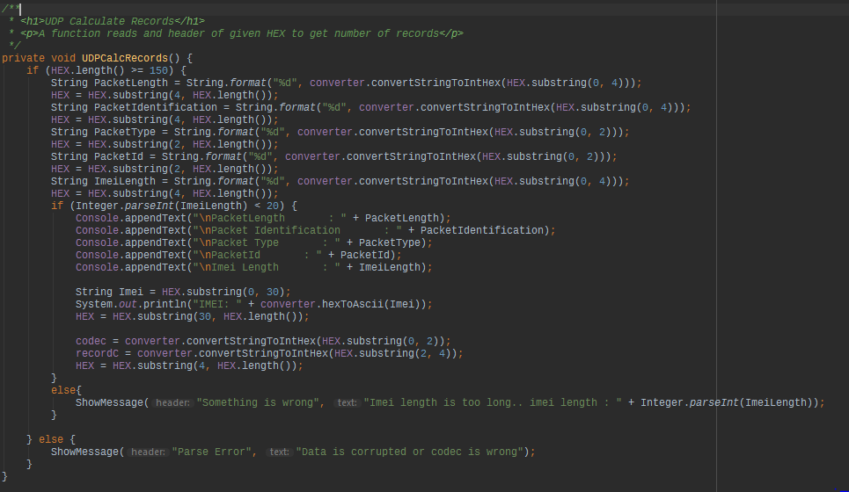
UDP Calculate Records in Parser class
If we choose to parse UDP type then the process would be same except for calculation part. Here it parses the header and checks for imei if its length is not longer than 20 digits. After that it parses the rest of data and returns number of records, the parsing process is the same as the TCP.
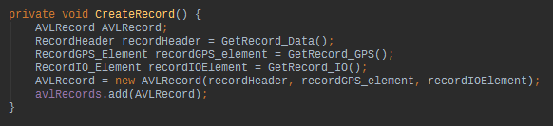
Create Record in Parser class

After getting record count on data, we run through the for loop, the Create Record method simply creates record header, GPS and IO elements objects to be added later on into the AVL Record object. First it calls out the header, then gps and finally the IO.

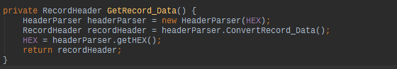
Get Record Data in Parser class

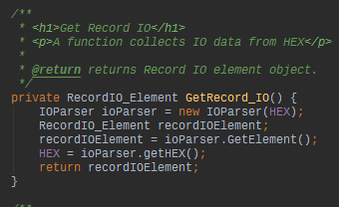
Get Record IO in Parser class

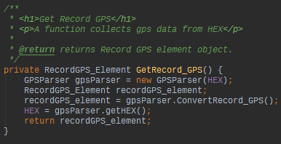
Get Record GPS Parser class

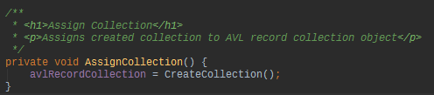
Assign Collection in Parser class
Once we finish our for loop we call method Assign Collection to declare avl Record collection.

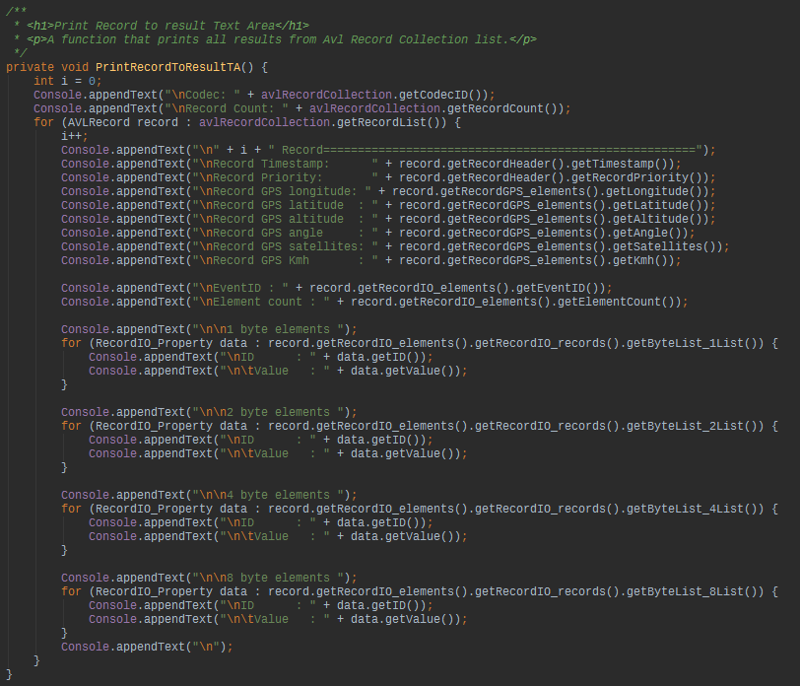
Print Record To Result Text Area in Parser class
Finally, after parsing process the object of avl Record Collection is ready to be used for printing out the whole results. It runs through every record to print out every record.

Listeners flowchart
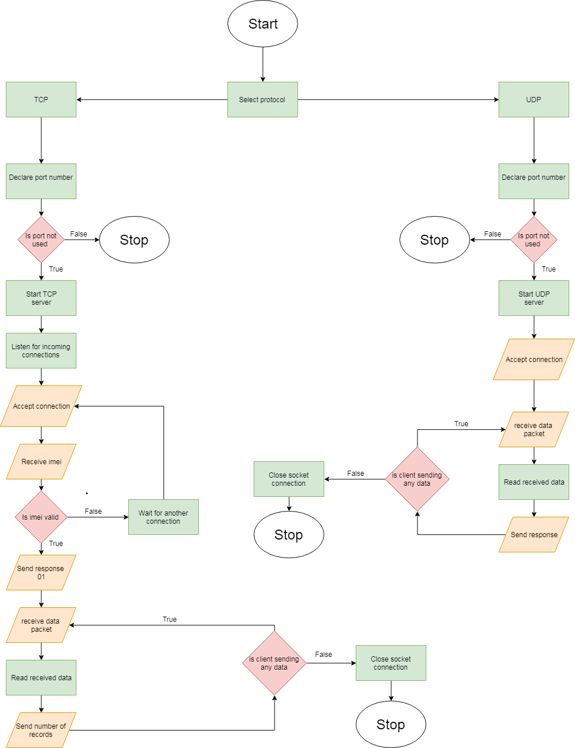
Illustration 2: Flow char of tcp and udp listeners

TCP part
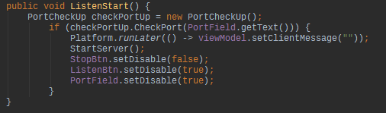
Listen start method in TCP View class
In the TCP listener when we enter protocol number and press “Listen” we first check if port that we want to use for listening is even available.

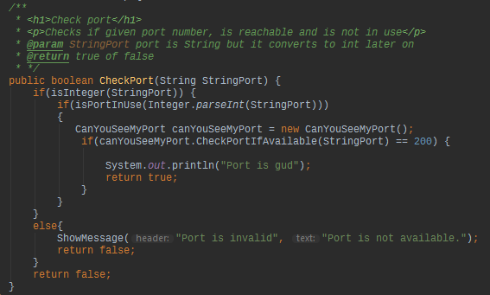
Check Port method in Port Check Up Port class
The Check port method returns true or false results. If port is in use it will return false and show message box, otherwise it should return true saying that port is not in use and is good to go.

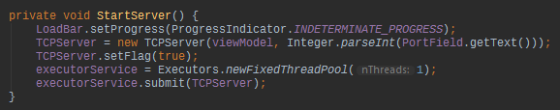
Start Server method in TCP View class
Later on we initialize server with Start Server method in which we call executor service to run our server.

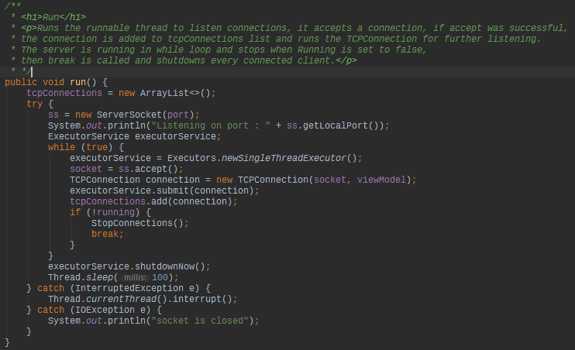
Run method in TCP Server class
Run method runs the server thread in which creates a server socket with declared port number. In While loop the listening starts and waits for the connections, once connection is established it will call out the tcp connection object to communicate with the device, it will put into the executor service and add to connections list. The server runs until we press “Stop” which calls to set running to false and causes to interrupt the server thread and all connections that are active.

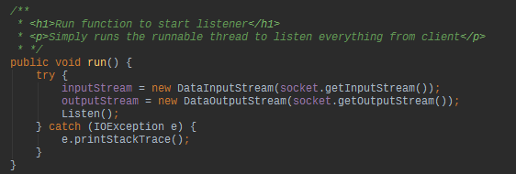
Run method in TCP Connection class
The TCP connection run method declares input and output streams and has one method call Listen.

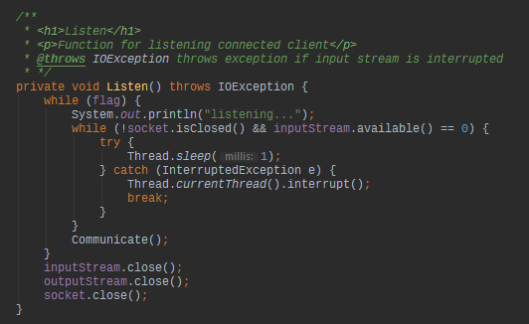
Listen method in TCP Connection class
The Listen method is responsible for listening. The while loop runs until we set flag to false, the while loop can also be break if device disconnects from the server. While loop is running we call our method Communicate.

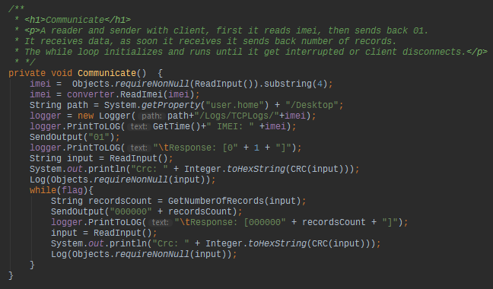
Communicate method in TCP Connection class
This method is mainly used to communicate with the device, as soon it receives imei it responds with byte 01, later on once it receives data packet we start another loop to send and receive data packets by receiving it and sending number of records. The loop is also breakable by setting flag to false. It logs at the same time as it communicates.

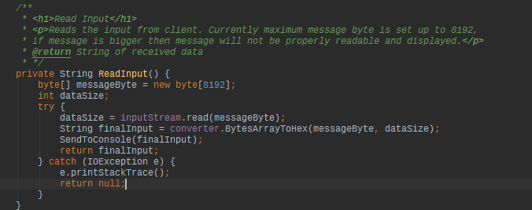
Read Input method in TCP Connection class
Currently it can receive up to 8192 bytes of data, it puts the received data to byte array and converts to hex for readability and further usages.

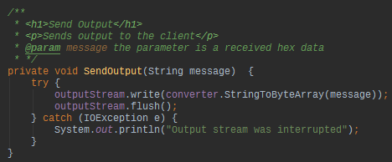
Send Output method in TCP Connection class

Send Output method simply converts string to byte array and sends it to device.

UDP part

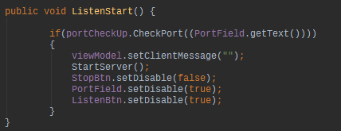
Listen start method in UDP View class

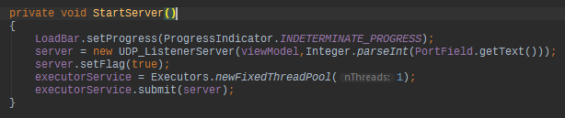
Start server method in UDP View class
The UDP start server starts the same way as TCP. It checks the port for availability and starts the server if its available.

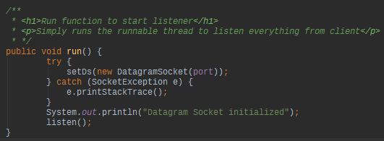
Run method in UDP Listener server class
The run method initializes DatagramSocket with declared port number, later on it calls listen method to do the listening.
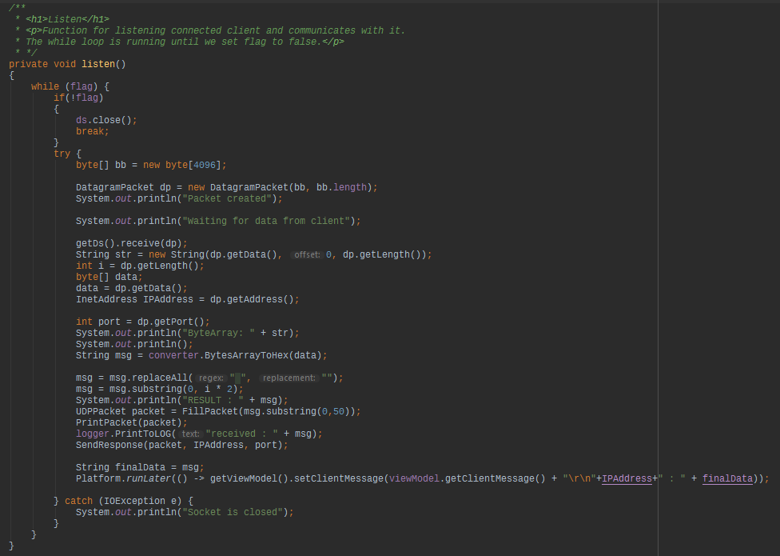
Listen method in UDP Listener server class
This method is the main method for listening UDP connections. The while loop runs until we change flag to false. It creates a datagram packet byte array of 4096 length and waits for client to receive the data. Once client sends the data packet we store it in DatagramPacket (dp) and use it for reading. Secondly we convert data packet to data byte array to convert it to hex. Then we read the hex and send feedback to client.

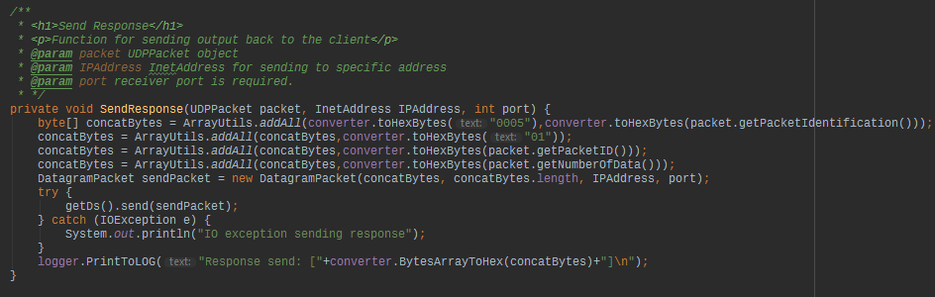
Send Response method in UDP Listener server class
The send response method for sending the feedback, we concat multiple arrays into one. So we would generate a single byte array to send it.

